OS Lab – Week 10,11

NAME: SIDDHARTHSHENOY

SRN: PES2201800499

Section: CSE-E

PROGRAMS FOR EXECUTION AND SUBMISSION:

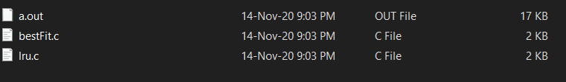

1. Write a C Program to implement paging using Best-fit algorithm.

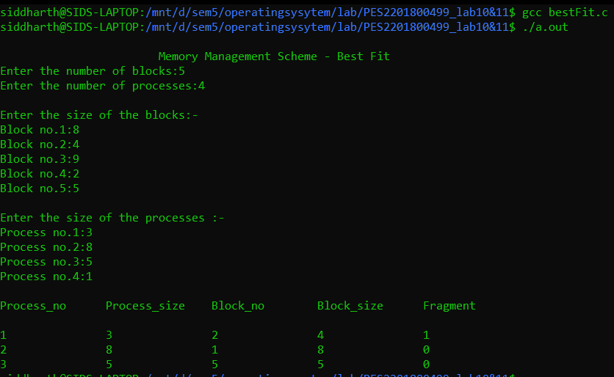

2. Write a C Program to implement LRU algorithm.

